Full-text Article Writing Guide
Title in 1 or 2 lines, B Nazanin font 14pt

The first author, the second author (Font: B Nazanin, font size: 12 bold)
1- Title and affiliation of the first author (B Nazanin 12 pt) (Font: B Nazanin, font size: 12)
2- Title and affiliation of the second author (B Nazanin 12 pt) (Font: B Nazanin, font size: 12)
An instance of Governmental Universities, Institutes for Higher Education, and Azad University
The students must be the first author, and their supervisor should be the second and corresponding author of the article.
Ali Amiri, Maryam Abbasi*, and…
1- Department ............., Faculty ......., South Tehran Branch, Islamic Azad University, Tehran, Iran
2- Assistant Professor of Management, University of Guilan, Rasht, Iran
* Corresponding author: maryam.a@gmail.com

Summary (Font: B Nazanin, font size 12 bold)
Each article needs to be summarized in one paragraph, with a margin of 30 mm from the right and 25 mm from the left. In this section, the topic, objectives, methodology, and findings of the research are stated independently, but no introduction should be included. The font of this section is B Nazanin 12pt.

Keywords: minimum three and maximum seven words separated by commas (B Nazanin 12pt) (Font: B Nazanin, font size: 12)

1. Introduction (with two lines 9pt distance from keywords)
This guide is designed to help the authors write Persian articles according to the articles' standard format at this conference. All authors are required to adhere to these criteria. It is worth noting that the present text has been written in accordance with the same criteria and can be used as a template (after removing the signs and additional explanations). (B Nazanin 12 pt) (Font: B Nazanin, font size: 12)
The authors need to write Persian articles in Microsoft Word 2007 software using B Nazanin 12pt font with single line spacing. The article text must be written in a single column with a margin of 30 mm from the right, 25 mm from the left, and 30 mm from the top and bottom of the paper. Each section's title should be written in B Nazanin 12 pt, Bold font, with the section number being two blank lines away from the previous section and one blank line from the text. The first line of all paragraphs, except for the first paragraph of the text, should be indented 12 mm.

2. Submission of full articles (B Nazanin 12 pt, Bold) (Font: B Nazanin, font size: 12 bold)
All full-text papers will be assessed by the conference’s reviewers. To this end, the article’s file should be sent via the conference website in doc format, prepared according to this guide. Moreover, the file must contain the article's text and all its components, including figures and tables.
The author of the article will be informed concerning the procedure of article acceptance. However, the latest status of articles at any time could be tracked through the conference’s website. As for the accepted articles, the authors must apply possible revisions suggested by the reviewers and upload the final version to the conference website before the deadline.

3. Maximum pages (B Nazanin 12 pt, Bold) (font: B Nazanin, font size:12 bold)
Minimum pages: 10 pages. The maximum pages, including the text and all its components such as figures and table: 20 pages.

4. Subtitle (B Nazanin 9 pt, Bold) (font: B Nazanin, font size: 9 bold)
Subtitles should be written in B Nazanin 9pt font.

5. Equations (B Nazanin 12pt, Bold) (font: B Nazanin, font size:12 Bold)
All equations must be left-aligned in Times New Roman font and proper size (preferably 12pt). The number of each equation should be mentioned sequentially in parentheses at the bottom right. The following equation is presented as an example:
Where and 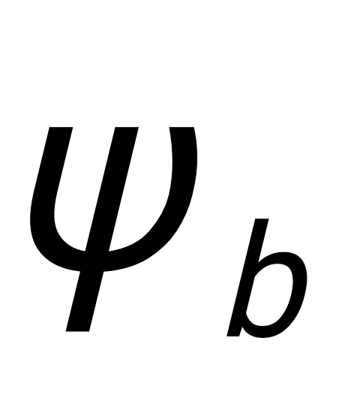 are variables ... for a particle with velocity in direction and time.

6. Definition of variables (B Nazanin 12 pt, Bold) (font: B Nazanin, font size: 12 bold)
Since the current format does not provide a separate space to list and define all variables, all variables must be fully defined immediately after the article's introduction section (refer to the definition of variables after Equation (1).

7. Units (B Nazanin 12 pt, Bold) (font: B Nazanin, font size: 12 Bold)
The international system of the unit (SI) is the only acceptable system for presenting problems. In special cases where it is necessary to state the problem in other systems, relevant SI standard equivalents must be mentioned. The units for the values ​​presented in the tables or the titles of figures should be noted.

8. Figures (B Nazanin 12 pt, Bold) (Font: B Nazanin, font size: 12 Bold)
All shapes and drawings should be presented immediately in the text after the first introduction. Figures must be drawn clearly with acceptable quality. Letters, symbols, and titles should be legible and separable. Each form has a separate reference number that must be cited in the text (Figure 1). Each figure also has a stand-alone title written in the font (B Nazanin 12pt Bold) below the figure. (B Nazanin 12 pt) (Font: B Nazanin, font size 12)

9. Tables (B Nazanin 12 pt, Bold) (font: B Nazanin, font size 12 Bold)
All tables should be inserted in the text directly after the first introduction. Letters, symbols, and titles should be legible and separable. Each table has a separate reference number that must be cited in the text. Each table also has a stand-alone title (B Nazanin 12pt Bold) written at the top of the table. A blank line at the top and bottom of the table separates it from the rest of the text. See Table 1 as a template.

Table 1- Parameters calculated in two sections
 | V_{p}, m/s | T, K
Results of section 1 | 18 | 311
Results of section 2 | 24 | 294

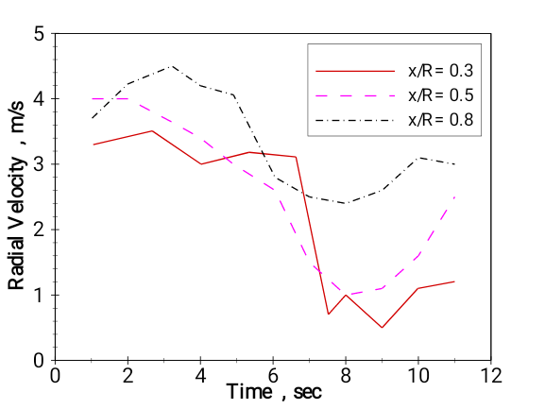
Figure 1 - Radial velocity changes versus time (B Nazanin 12 pt, Bold) (font: B Nazanin, font size 12 Bold)

12. Conclusion (B Nazanin 12 pt, Bold) (font: B Nazanin, font size 12 Bold)
Each article should provide specific explanations to summarize the research results presented in the conclusion section.

11. Acknowledgement (B Nazanin 12 pt, Bold) (font: B Nazanin, font size 12 Bold)
If necessary, a short Acknowledgement section can be added before presenting the list of references.

12. References (B Nazanin 12 pt, Bold) (Font: B Nazanin, font size 12 Bold)
Article referencing is based on APA, an example of which is shown in the following.

Corresponding author: details of the first author Email:

